

**Tribhuvan University**

**Faculty of Humanities and Social Sciences**

**ONLINE CAR RENTAL SYSTEM**

**A PROJECT REPORT**

**Submitted to**

**Department of Computer Application Kathmandu College of Central State**

***In partial fulfilment of the requirements for the Bachelors in Computer Application***

Submitted by

Name: Aman Rauniyar

#### Under the supervision of



**Tribhuvan University**

**Faculty of Humanities and Social Sciences**

**Kathmandu College of central state**

**Solteemode, Kalimati**

**Supervisor’s Recommendation**

I hereby recommend that this project be prepared under my supervision by Aman Rauniyar **entitled “ONLINE CAR RENTAL SYSTEM”** in partial fulfilment of the requirements for the degree of Bachelor of Computer Application is recommended for the final evaluation.

**SIGNATURE**

Jaya Ram Gautam

 **SUPERVISOR**

Lecturer

BCA Department

Kathmandu College of central state

Solteemode, Kalimati



**Tribhuvan University**

**Faculty of Humanities and Social Sciences Kathmandu College of central state**

**Solteemode, Kalimati**

**LETTER OF APPROVAL**

This is to certify that this project was prepared by Aman Rauniyar **entitled “ONLINE CAR RENTAL SYSTEM”** in partial fulfilment of the requirements for the degree of Bachelor in Computer Application has been evaluated. In our opinion, it is satisfactory in the scope and quality as a project for the required degree.

|  |  |
| --- | --- |
| <<Signature of Supervisor>>    <<Name of Supervisor>>  BCA Department  Kathmandu College of central state  Solteemode, Kalimati | <<Signature of Campus chief>>    <<Name of Campus chief>>  Kathmandu College of central state  Solteemode, Kalimati |
| **Internal Examiner** | **External Examiner** |

**Kathmandu College Of Central State**

**Ref no:**

**Date:**

**Subject: Approval of project proposal**

The project entitled “**ONLINE CAR RENTAL SYSTEM**” proposed by Mr. Aman

Rauniyar for the partial fulfilment of the requirement for Bachelor in Computer Application (BCA), the fourth semester has been approved for further development.

**Proposal Evaluation committee**

**1. ______________**

**2.________________**

**3.________________**

**4.________________**

**_________________**

**Mr.**

**Campus Chief.**

**ABSTRACT**

The importance of information and efficient information management is steadily increasing due to the evolution of new technologies and high-capacity storage media but also because growing market dynamics raise information needs. A marketing decision support system can be of particular importance as it supports organizations in collecting, storing, processing, and disseminating information, and in the decision-making process by providing forecasts and decision models (Little 1979).

The following article provides insights into a successful implementation of a marketing decision support system in tourism. Based on findings on the analysis of the system’s protocol files, it discusses the information needs in tourism management.

Table of Contents

Chapter 1 Introduction 6

Introduction to Proposed project 6

Problem Statement 7

Objectives 7

Scope and limitation 7

Scope 8

Limitation 8

Chapter 2: Literature Review 8

Literature Review 8

Bot 13

Chapter 3: Methodology 13

System Development Methodology 13

System Analysis 14

System Requirements 14

Feasibility study 15

Tools we use: 17

REQUIREMENTS MODELLING 17

System Design 18

Use Case Diagram 19

Data Flow Diagram 22

Chapter 4 Conclusion 24

Expected Output 24

BIBLIOGRAPHY AND REFERENCES 25

Books Used: 25

References Used: 25

Appendices 26

# **Chapter 1 Introduction**

## Introduction to Proposed project

Changes to technology over time have affected many aspects of life. The way we lived in the past is different to the way we live today and this is vastly due to the changes in technology. Technological changes affect the way we work, travel, communicate and play. As students learn about the impact of changing technology, they can explore current digital systems and their use. Current digital systems such as computers, smartphones, tablets and laptops have evolved over time. The availability of the Internet provides us with ready access to information anytime, anywhere. Connectivity enables us to conduct our shopping and banking online. We can stay in touch and communicate instantly with friends and family anywhere in the world. Students can consider the impact of these technological changes as they compare a current digital solution with the way this might have been solved in the past. Whereas, renting car is a part of many people’s travel plan and used in all around the world to travel from place to place. **Online Car Rental System** will provide simple solution for rental companies. After considering the wide range of requirement of car we have developed the system which is appropriate for both company and the client.

The objective of the proposed Online Car Rental System, the users are able to enter the company's website for searching and reserving their favorite cars easily through the Internet and it can be accessed anywhere anytime in the world.

With this proposed system, the achievable advantages are as follows:

View cars with affordable pricing. The rental pricing for each type of cars is clearly listed in the propose system to enable the registered and unregistered users to compare themselves with their competitors. The listed pricing is affordable for employed and unemployed employees or citizens who their incomes range are between low-medium levels to upperupper level.

Post suggestions, comments, and complaints in the form of feedback. The registered and unregistered users are able to post their suggestions, comments and complaints through the propose system. Therefore, the company will improve themselves from time-to-time to ensure that their customers are satisfied with their services given.

The **Online Car Rental System** is a based-on **PHP** that allows you to transact online booking for car rentals. The system is using PHP, JavaScript and MySQL for database. The system is very straight forward. After you log in as admin, you can create a brand and add vehicles used for booking online. The system also has testimonials and a contact us page so the customer can give their feedback and contact the site owner. The customer can register on the website and select which vehicle they’d like to rent. The project's website has a pleasant user interface and it's user-friendly.

This project is designed so as to be used by Car Rental Company specializing in renting cars to customers. It is an online system through which customers can view available cars, register, view profile and book car.

## Problem Statement

It is not the fact that the Online Car Rental System already doesn’t exist. The Online Car Rental System that are already available are not interactive and people might find some issues with their services. The current situation of the Online Car Rental System were analysed, and the following problems were found.

The problem of the current Online Car Rental System is listed below:

* There is a Lack of a computerized Database Management System, data, or information that is in a file format is hard to access, and it takes a lot of time to give output.
* There may be a chance of a system crash or data stolen in the file system due to a weak database management system.
* The individual who needs a car must contact a rental car company and contract out for a vehicle.
* Service may be slow, or the system may be inactive for visitors.
* General people may not have the access to watch the facility provided by the agency.

## Objectives

The main objectives of this project are listed below:

* Enhance Business Processes: To be able to use internet technology to project the rental company to the global world instead of limiting their services to their local domain alone, thus increase their return on investment (ROI).
* Online Vehicle Reservation: A tools through which customers can reserve available cars online prior to their expected pick-up date or time.
* Customer’s registration: A registration portal to hold customer’s details, monitor their transaction and used same to offer better and improve services to them.
* Group bookings: Allows the customer to book space for a group in the case of weddings or corporate meetings (Event management).

## Scope and limitation

### Scope

This project traverses a lot of areas ranging from business concept to computing field, and required to perform several researches to be able to achieve the project objectives. The area covers include:

* Car rental industry: This includes study on how the car rental business is being done, process involved and opportunity that exist for improvement.
* PHP Technology used for the development of the application.
* General customers as well as the company’s staff will be able to use the system effectively.
* Web-platform means that the system will be available for access 24/7 except when there is a temporary server issue which is expected to be minimal.

### Limitation

* People in rural areas with no stable internet facilities may not be able to use this system.
* This system is a web-based system, and its mobile application is not available.
* This system requires an internet connection and the user must be a computer- literate person.

# Chapter 2: Literature Review

## Literature Review

A car rental, hire car, or car hire agency is a company that rents automobiles for short periods of time, generally ranging from a few hours to a few weeks. It is often organized with numerous local branches which allow a user to return a vehicle to a different location, and primarily located near airports or busy city areas and often complemented by a website allowing online reservations.

Renting a car assists people to get around even when they do not have access to their own personal vehicle or don't own a vehicle at all. The individual who wants to rent a car must first contact the car rental company for the desired vehicle done online. At this point, this person has to supply some information such as; dates of rental, and type of car. After these details are worked out, the individual renting the car must present a valid Identification card. Most companies throughout the industry make a profit based on the type of cars that are rented. The rental cars are categorized into the economy, compact, compact premium, premium, and luxury. And customers are free to choose any car of their choice based on their purse and availability of such a car at the time of reservation.

Alongside the basic rental of a vehicle, car rental agencies typically also offer extra products such as a global positioning system (GPS), entertainment systems, and portable Wi-Fi and child safety seats.

#### DEFINITION AND EXPLANATION OF MAJOR TERMINOLOGIES ADMINISTRATOR

Administrator or manager is the person who will manage the entire system. He is allowed to reassigned cars to clients according to his priority; he can edit information such as prices of cars, other available services, etc.

#### CLIENT

This user will register to be a member to use the online system of this online car rental management system. This online system comes with reservation and booking for any car of their choice.

#### SALINA (RENTER)

salina is the one who is the need of the car or the center of the car also the salina entitles the right of the usage of the car and at the same time, the Usha will offer him/her the features of the car.

**USHA (OWNER)**

usha is the owner of the car or of the automobile.

#### STEERING LOCK, GEAR LOCK, AND IMMOBILIZER

They are simple security devices, that are a more advanced security system that can be used to track down stolen vehicles.

A luxury car is a marketing term for a vehicle that provides luxury at an increased expense. It epitomizes quality, comfort and cutting-edge technology to deliver the ultimate driving experience. Some popular local makes include Audi, BMW, Mercedes-Benz, Volvo, and others.

Members of this family sport aerodynamic shapes and low profiles as they are dynamically inclined. A sports car is designed with performance in mind primary considerations can include high horsepower as well as superior handling and braking. Sport utility vehicles (SUVs) are vehicles similar to station wagons or estate cars, but they usually feature raised ground clearance and four-wheel drive for on or off-road capabilities.

Multi-purpose vehicles (MPVs), also known as minivans, are designed with maximum interior volume in mind - typical MPVs can carry anywhere between six to eight passengers. Larger and taller than sedans, hatchbacks, or station wagons, MPVs are most useful for large families.

A hybrid vehicle is a vehicle that uses two or more distinct power sources to move the vehicle. The most common type is the hybrid electric vehicle (HEV), which combines an internal combustion engine and one or more electric motors. However, other mechanisms to capture and use energy are also included.

#### REVIEW OF PUBLICATIONS THAT ARE RELATED TO THE PROJECT

The first car reservation company started by Saunders witnessed exponential growth following which many other businessmen started their car-reservation firms in America. Though Saunders experienced bankruptcy during the economic collapse in America, others who followed him continued to outlive their business opportunity. Walter Jacobs and John Hertz were the ones who successfully continued their operation. When the levels of growth started reaching extreme heights John Hertz could not sustain entered into a venture with the automobile giant, General Mills.

After this, America witnessed the emergence of Warren Avis car reservation and National car reservation in America (Gandhi, 2013).

##### The First Online Car Rental System: Avis Wizard System

Avis Car Rental and its subsidiaries operate one of the world's best-known car rental brands. Avis has a long history of innovation in the car rental industry and is one of the world's top brands for customer loyalty. Avis also created the first online computerized car rental reservation system with data processing and information management system enables them to process over one million incoming customer inquiries each day, as well as the ability to place or modify reservations. Additionally, the Wizard System is linked to all major travel distribution networks worldwide and provides real-time processing for travel agents, travel industry partners such as airlines, corporate travel departments and individual consumers through their websites or calls to contact centers. (Wikinvest.com, 2008)

##### The Weakness of Avis Wizard System

The system lacks some few things which could help it function properly. Here are some of the weaknesses outlined. They need to do a few enhancements to the frontend website, to catch up to Rental cars. The user interface is poorly designed as compared to how a modern system should be. It also has a language barrier thus it has been designed using one language. I think the system should be designed with multi-languages to be accessed by everybody from anywhere.

##### Car Rental Solution: Easy Rent Pro

Easy Rent Pro was established in 2006 and has since then been developing costeffective software solutions for vehicle rental operations worldwide. Easy Rent Pro is the most complete car rental solution for the vehicle rental industry. They are committed to bringing them the best rental vehicle software available today and in the future. Customers can connect to the Internet and reserve the vehicle of their choice on their own online reservation site. This online rental car booking system gives the customers an immediate view of availability, rates and instant booking confirmation.

##### Functionality of the Easy Rent Pro System

It features sophisticated rate options, fleet management functions to give a powerful online reservation system. The customer then chooses the proper class of vehicle and checks the availability of the specific dates he wants and automatically receives a confirmation number. The availability can be listed by vehicle, class or rate. Travel agencies and other references can submit their customer's reservations through the reservation central by simply entering their access code and commission rates will be calculated automatically and cumulated on their monthly report. This reservation system is available only in English (easyrentpro.com, 2013).

##### Short Falls of the System

Vehicle management is a problem when the vehicle tag numbers are reuse since it uses the tags as the primary index key for vehicles so if you want to use the same tag on a different vehicle you have to add a digit to the front or end of the tag number otherwise it will overwrite the pre existing vehicle information. It also has a language barrier thus, it has been designed using one language. I think the system should be designed with multi-languages to be accessed by everyone.

#### SYNTHESIS ON THE REVIEW OF RELATED LITERATURE

According to the literature mentioned, online car rental system has been widely used in order to provide an instant car confirmation service to the web site's visitors, hopefully turning them into bookers. An Online Reservation System allows people to receive reservation 24 Hours a day, therefore their car rental reservation services are always open. A lot of car rental companies are now using the power of the Internet into making their businesses successful because just like what Avis said their system enables them to process over one million incoming customer inquiries each day, rental rates and vehicle availability, as well as the ability to place or modify reservations.

#### CHALLENGES FACING THE CAR RENTAL INDUSTRY

Car Rental operators and vendors face different challenges while managing reservations and resources. Some of the challenges and ways to curb them are listed below:

▪ Complex Booking & Pricing Management: A car rental management software can make it easy to offer new deals, managing prices and monitoring the performance. ▪ Improving Customer Service and Transparency. By providing a user-friendly GUI

(Graphical User Interface) and a simple booking experience would solve the issue. ▪ Brand Awareness: There are so many new rental companies with new applications or software in the market and they struggle for a reputed name in the market. Foremost it is important to provide quality services because a bad review about your offering can spoil your image.

▪ New Independent Car Rental Companies: keep yourself updated with new technologies and always try to bring some new offers to grab customer attention.

## Bot

This helps the user to know the solutions of frequently asked questions of all users.

# Chapter 3: Methodology

## System Development Methodology

There are many software design methodologies that could be used in creating the complaint system in android version but a few of the design methodologies will be highlighted namely: the spiral model waterfall model, incremental spiral model, and AJAX+SSH .

Design and Realization of Car Rental Management System Based On AJAX+SSH:

A research article written by Zhang Li proposed an enterprise-class development program of car rental management system based on AJAX+SSH. Ajax is a technique for creating fast and dynamic web pages. It allows web pages to be updated asynchronously by exchanging small amounts of data with the server behind the scenes, whereas Secure Shell (SSH) is a cryptographic network protocol for operating network services over an unsecured network. The Ajax application program is usually divided into three main parts namely the model view and controller. These parts of the Ajax application program do not work for hand in hand executing their tasks separately. According to his design, the system was divided into four parts namely the presentation layer, controller layer, business logic layer, and data access layer. His car rental management system was designed into such layers to facilitate the ease of system maintenance.

In designing the system, the presentation layer was first integrated. Zhang Li built the presentation layer with the aid of the AJAX. The view was constructed using java server pages. The second step in designing the car rental management system was to integrate the control layer. The control layer had four set of tasks to complete thus;

1. Accepting customer’s request.
2. Choosing suitable model components to operate the corresponding business logic. according to customer’s request.
3. Achieving results from business logic.
4. Choosing suitable view components and feeding them back to customers according to results.

## System Analysis

System analysis is the phase in which facts and information are collected, problems are identified, and the system is decomposed into its components. Mainly, system analysis is done to understand the purposed system and identify its objectives and goals. In simple words, at the end of the phase, it is identified what the system should do. This phase is helpful to know about the business needs and process needs.

### System Requirements

**Hardware Requirements:**

* PIV 2.8 GHz Processor and Above
* RAM 512MB and Above
* HDD 40 GB Hard Disk Space and Above

**Software Requirements:**

* WINDOWS OS (XP / 2000 / 200 Server / 2003 Server)
* Visual Studio .Net 2008 Enterprise Edition
* Internet Information Server 5.0 (IIS)
* Visual Studio .Net Framework (Minimal for Deployment) version 3.5 ❖ SQL Server 2005 Enterprise Edition

### Feasibility study

Preliminary investigation examines project feasibility, the likelihood the system will be useful to the organization. The main objective of the feasibility study is to test the Technical, Operational and Economical feasibility for adding new modules and debugging old running system. All system is feasible if they are unlimited resources and infinite time. There are aspects in the feasibility study portion of the preliminary investigation:

* Technical Feasibility
* Operational Feasibility
* Economic Feasibility

##### Technical feasibility

The technical issue usually raised during the feasibility stage of the investigation includes the following:

* Does the necessary technology exist to do what is suggested?
* Do the proposed equipment’s have the technical capacity to hold the data required to use the new system?
* Will the proposed system provide adequate response to inquiries, regardless of the number or location of users?
* Can the system be upgraded if developed?
* Are there technical guarantees of accuracy, reliability, ease of access and data security?

Earlier no system existed to cater to the needs of ‘Secure Infrastructure Implementation

System’. The current system developed is technically feasible. It is a web-based user interface for audit workflow at NIC-CSD. Thus, it provides an easy access to the users.

The database’s purpose is to create, establish and maintain a workflow among various entities in order to facilitate all concerned users in their various capacities or roles. Permission to the users would be granted based on the roles specified. Therefore, it provides the technical guarantee of accuracy, reliability and security. The software and hard requirements for the development of this project are not many and are already available in-house at NIC or are available as free as open source. The work for the project is done with the current equipment and existing software technology. Necessary bandwidth exists for providing fast feedback to the users irrespective of the number of users using the system**.**

##### Operational feasibility

Proposed projects are beneficial only if they can be turned out into information system. That will meet the organization’s operating requirements. Operational feasibility aspects of the project are to be taken as an important part of the project implementation. Some of the important issues raised are to test the operational feasibility of a project includes the following: -

* Is there sufficient support for the management from the users?
* Will the system be used and work properly if it is being developed and implemented?
* ·Will there be any resistance from the user that will undermine the possible application benefits?

This system is targeted to be in accordance with the above-mentioned issues. Beforehand, the management issues and user requirements have been taken into consideration. So, there is no question of resistance from the users that can undermine the possible application benefits.

The well-planned design would ensure the optimal utilization of the computer resources and would help in the improvement of performance status.

##### Economic feasibility

A system can be developed technically and that will be used if installed must still be a good investment for the organization. In the economic feasibility, the development cost in creating the system is evaluated against the ultimate benefit derived from the new systems. Financial benefits must equal or exceed the costs.

The system is economically feasible. It does not require any addition hardware or software. Since the interface for this system is developed using the existing resources and technologies available at NIC, There is nominal expenditure and economic feasibility for certain.

## Tools we use:

● Frontend

○ HTML

○ CSS

○ JS

Bootstrap

● Back-end

○ Python/Php

## REQUIREMENTS MODELLING

TESTING & DEBUGGING

Testing is the one of the most essential process that involve checking of the entire software files that helps in the proper functioning of the software. Testing provides a way of finding out the errors & faults that might have occurred during the development of the software. During the process of the testing of the software, all the necessary errors & faults that have occurred or arisen are traced & proper solutions regarding the errors. Are prepared.

Testing acts as an important phase of the software development life cycle. Testing basically depends upon following two factors:1. Error Faults. 2. Reliability.

Errors Faults defines the number of errors that have occurred during the development of the software that in effect have changed or diverted the entire process of the functioning of the software. The second important factor that comes out as result of testing is Reliability. By testing the entire software, we can easily find out the reliability of the software. So, testing provides a platform for the software developers to develop software that are error free and in effect, efficient and reliable.

Testing can be categorized into the following types depending on their use and purpose in the development of the software. They are:1. Functional Testing:Functional testing of the software comprises of testing of the function and modules that were created in the software and checking the accuracy of the functioning of the modules and functions that have been used in the proper and effective working of the software.

2. Structural Testing: -Structural Testing involves the process of testing the entire structure of the software that is developed (i.e. Logical as well as physical). All the logical steps related to the logical structure and the physical structure are tested for their accurate functioning and satisfaction for the developer.

Debugging: - Testing is the process of checking the errors, faults and failures that have occurred during the development or during the running of the system and which in turns have caused problems in the proper functioning of the system. Testing just provides a medium for searching out errors. On the other hand, de-bugging allows developers of the software to remove or make corrections on the errors that were found during testing of the software as de-bugging means, “removing of bugs”.

## System Design

Software design sits at the technical kernel of the software engineering process and is applied regardless of the development paradigm and area of application. Design is the first step in the development phase for any engineered product or system. The designer’s goal is to produce a model or representation of an entity that will later be built. Beginning, once system requirement have been specified and analyzed, system design is the first of the three technical activities -design, code and test that is required to build and verify software.

The importance can be stated with a single word “Quality”. Design is the place where quality is fostered in software development. Design provides us with representations of software that can assess for quality. Design is the only way that we can accurately translate a customer’s view into a finished software product or system. Software design serves as a foundation for all the software engineering steps that follow. Without a strong design we risk building an unstable system – one that will be difficult to test, one whose quality cannot be assessed until the last stage.

During design, progressive refinement of data structure, program structure, and procedural details are developed reviewed and documented. System design can be viewed from either technical or project management perspective. From the technical point of view, design is comprised of four activities – architectural design, data structure design, interface design and procedural design.

### Use Case Diagram

Actor and Use Case Description

Actor and use case description shows the detail description of interaction between the actors and their use cases. The description enables to have a proper understanding of how actor interacts with the system through their use cases.

|  |  |  |
| --- | --- | --- |
| **Actor** | **Use Case** | **Use Case Description** |
| Customer | Register as member | This use case describes the activities of the customer to register online and become a member. Customer's details are required as part of the registration. Login detail is automatically sent to the customer after successful registration. |
| Make  reservation | This use case enable customer to search and make reservation. Non-register customer will be directed to register before their reservation can be confirmed. Notification is automatically send to the customer after the task is completed. |
| Return car | This use case describes the event of customer returning the car borrowed, the use case extends "process rental" use case from the staff actor. |
| Give feedback | This use case is used by the customer to provide feedbacks/comment to the company; a confirmation notification will be send to the customer once a feedback has been submitted. |
| Staff | Add new car | This use case is used by the staff to add new car to the company's fleet database. Staff will need to login to activate this use case. |
| Update car details | This use case is used by the staff to edit and modify car details whenever there is new renewal (insurance, road tax). It allows the company to keep up-to-date record of their fleet. |
| Reply to customer’s feedback | This use case describes the event by which staff sends reply to customer's earlier feedback. It depends on `give feedback' use case from the customer. |
| Process rental | This use case described the event by which staff updates the system when customer pick up or when returning car. |
| Admin | Add new staff | This use case describes the event by which Admin add new staff detail to the company's staff database. It is invoke whenever a new staff join the company. |
| View report | This use case is used by the Admin to view transaction report. |

Table: Actors and Use Case Description **Use Case Diagram**



Admin



Staff



Customer



Reply to

customer's



Give

feedback/

comments



Update car details



Process rental



Register as member



Add new car



Make reservation



View report



Return car



extend

>>

<<

Figure: E-Car Rental System [use case] **Use-Case Dependency Diagram**

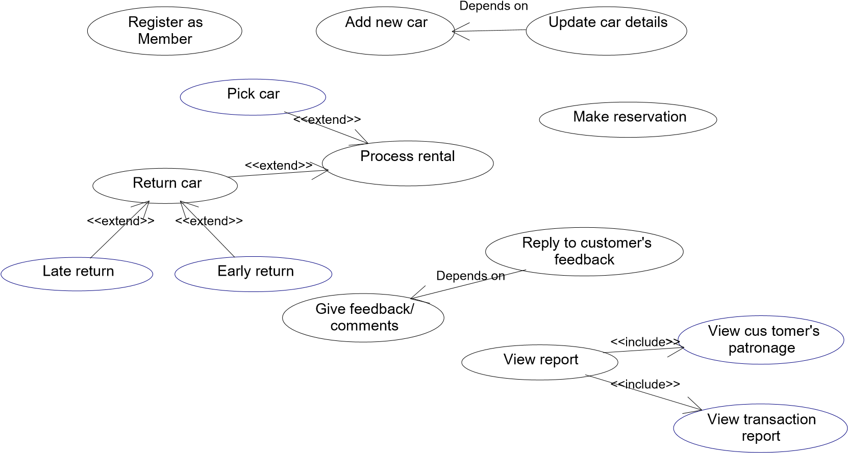



Figure: Use Case Dependency Diagram

## Data Flow Diagram

A Data Flow Diagram (DFD) is a graphical representation that depicts the information flow and the transforms that are applied as data moves from input to output.

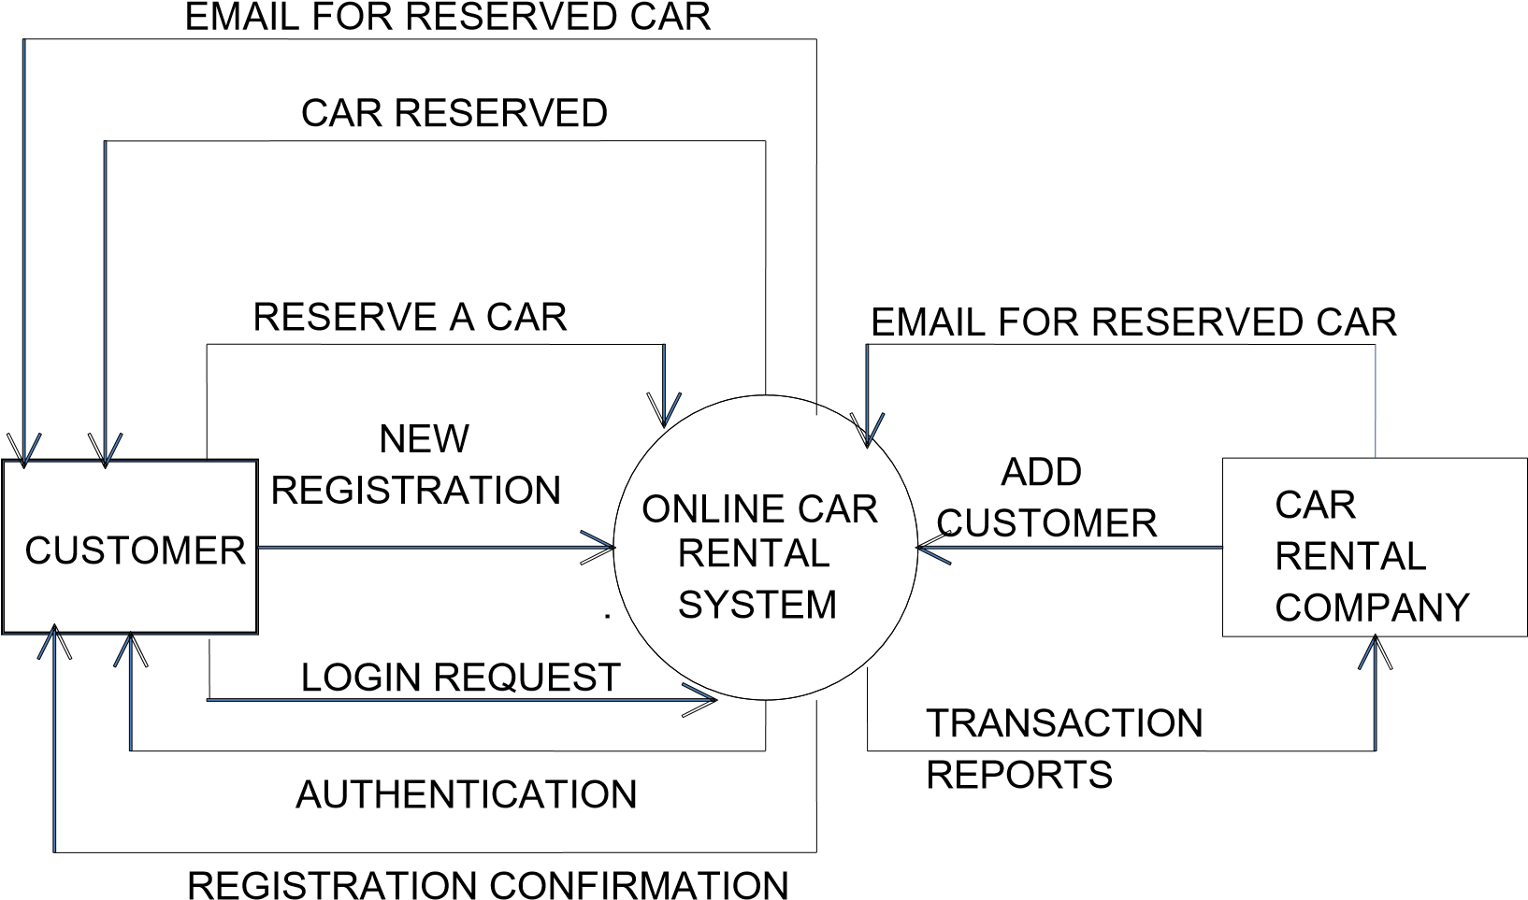

Figure: Level 0 DFD of Online Car Rental System In this diagram, Customer and Car Rental Company are the two entity sets.

Functions of Customer:

* New Registration
* Login Request
* Registration Confirmation by the System
* Reserve Car
* Car Issued by the System
* Email received for Reserved Car

Functions of Car Rental Company:

* Add Customer
* Send E-Mails for Reserved Car
* View Transaction reports

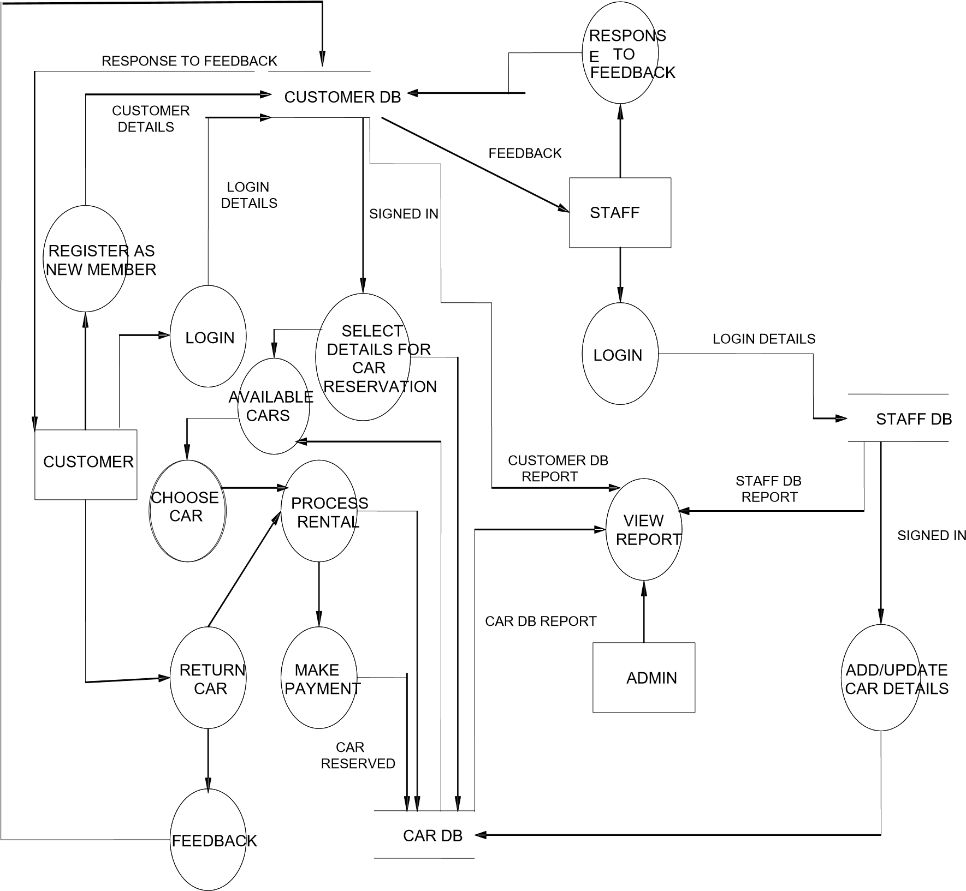

Figure: Level 1 DFD of Online Car Rental System

# Chapter 4 Conclusion

This project will be really helpful for solving the issues of car rental system. People can rely on this system to rent a car. This system has the betterment in the user interaction and transparency of car. Through this platform, people can be connected to the affordable car easily.

## Expected Output

Car rental business has emerged with a new goody compared to the past experience where every activity concerning car rental business is limited to a physical location only. Even though the physical location has not been totally eradicated; the nature of functions and how these functions are achieved has been reshaped by the power of internet. Nowadays, customers can reserve cars online, rent car online, and have the car brought to their door step once the customer is a registered member or go to the office to pick the car.

The web-based car rental system has offered an advantage to both customers as well as Car Rental Company to efficiently and effectively manage the business and satisfies customers’ need at the click of a button.

# BIBLIOGRAPHY AND REFERENCES

## Books Used:

* Software Engineering - R.S. Pressman
* PHP For Dummies
* PHP Begineers Guide By McGrawhill Publication
* Javascript By McGrawhill Publication

## References Used:

* <http://www.carrentingsolutions.com/>
* http://www.flashvortex.com/
* <http://www.imscart.com/car_rental_software.html>
* Wikipedia.org
* www.w3schools.com

# Appendices

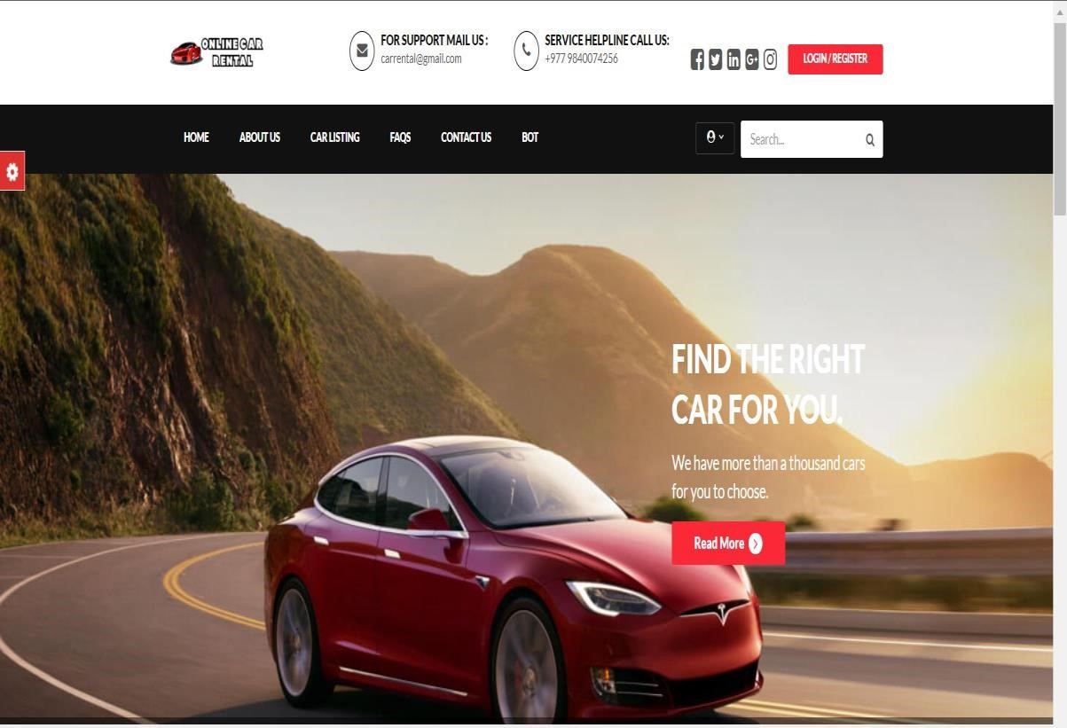

Fig : Homepage

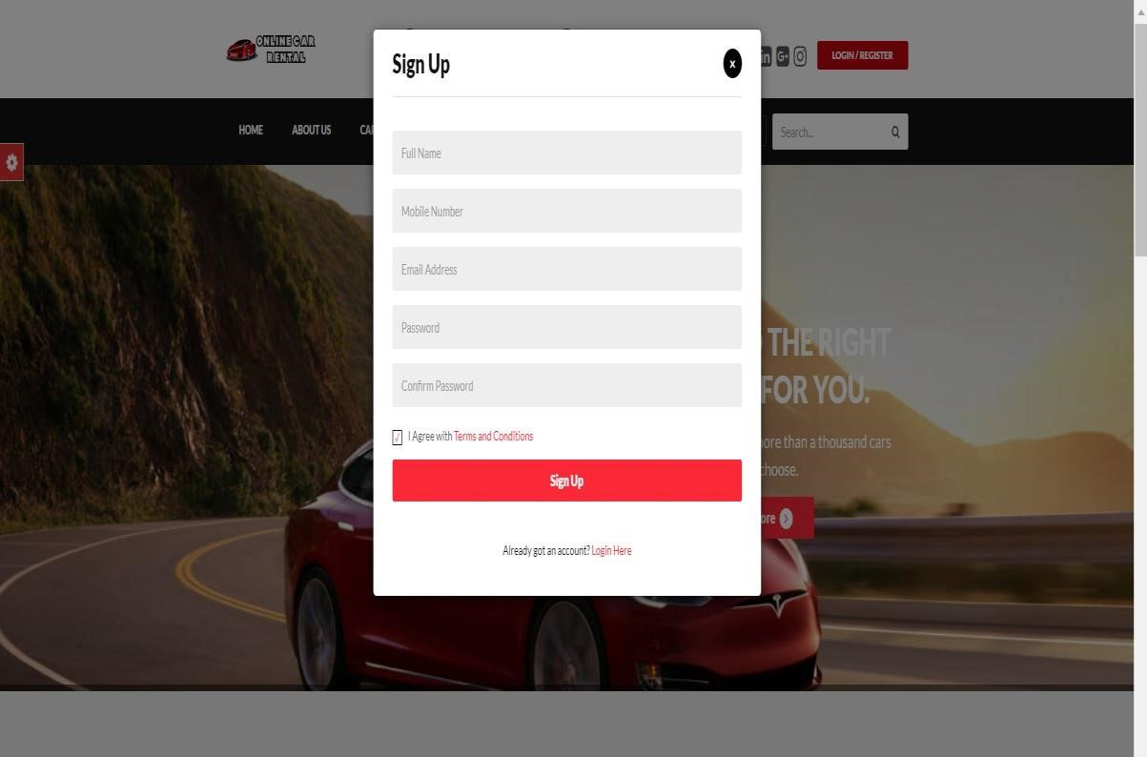

Fig : Signup

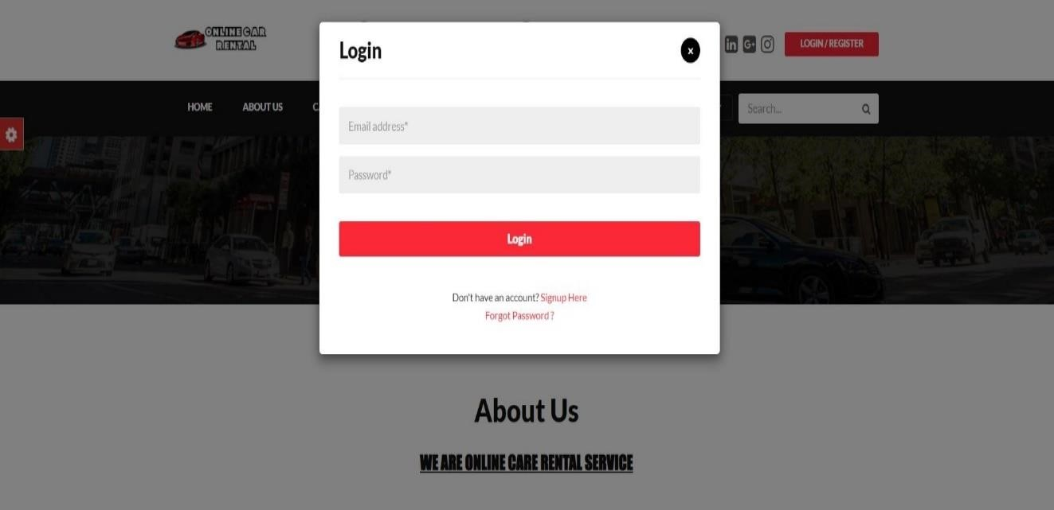

Fig : Login

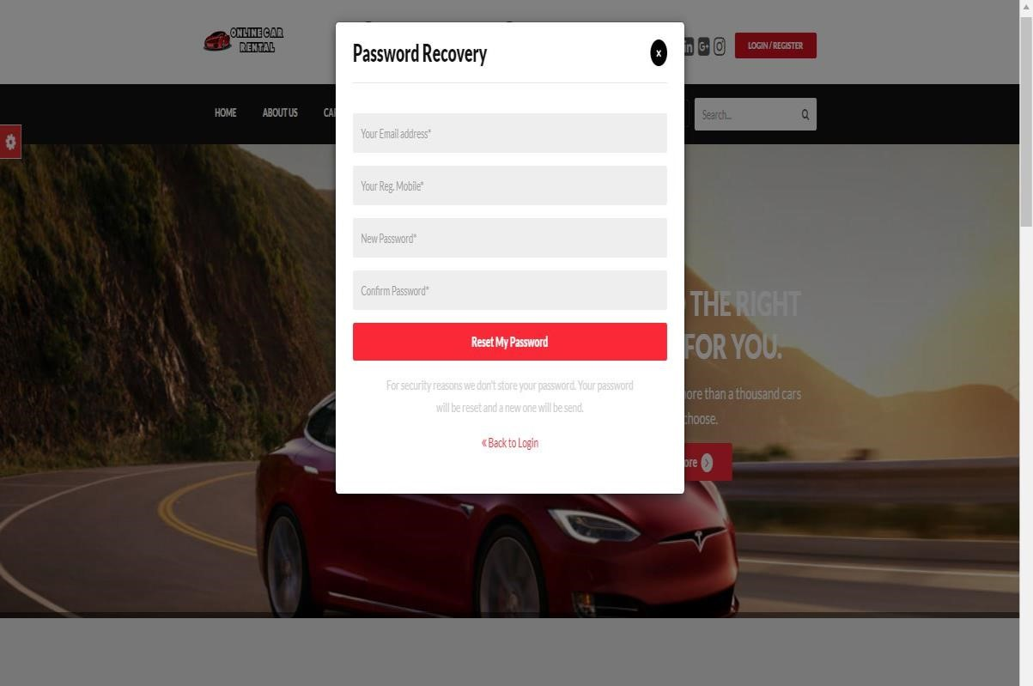

Fig : Password Recovery

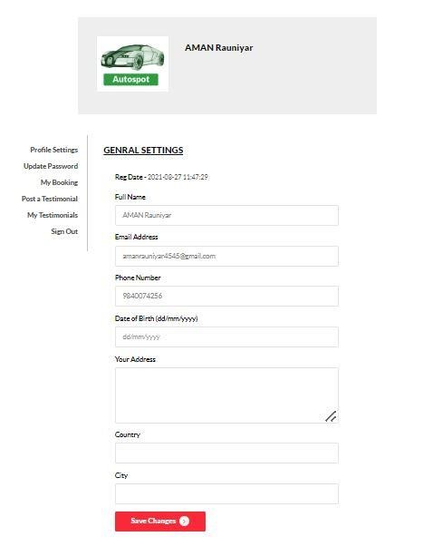

Fig : User Profile

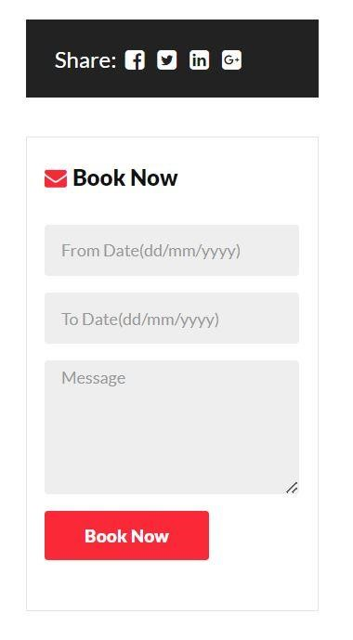

Fig : Booking Now

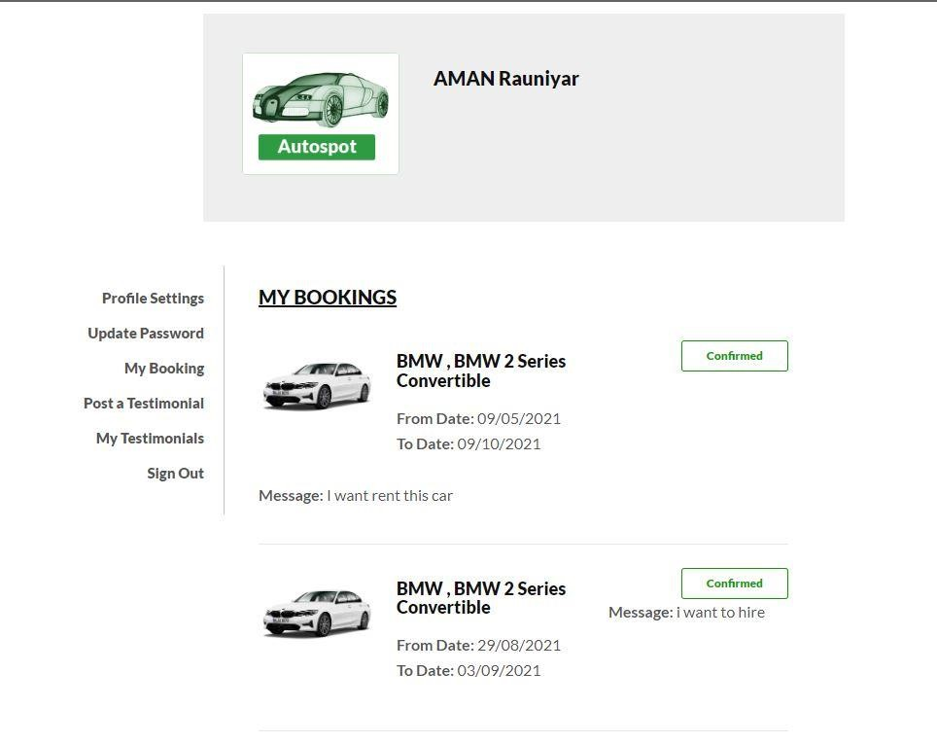

Fig : My Bookings

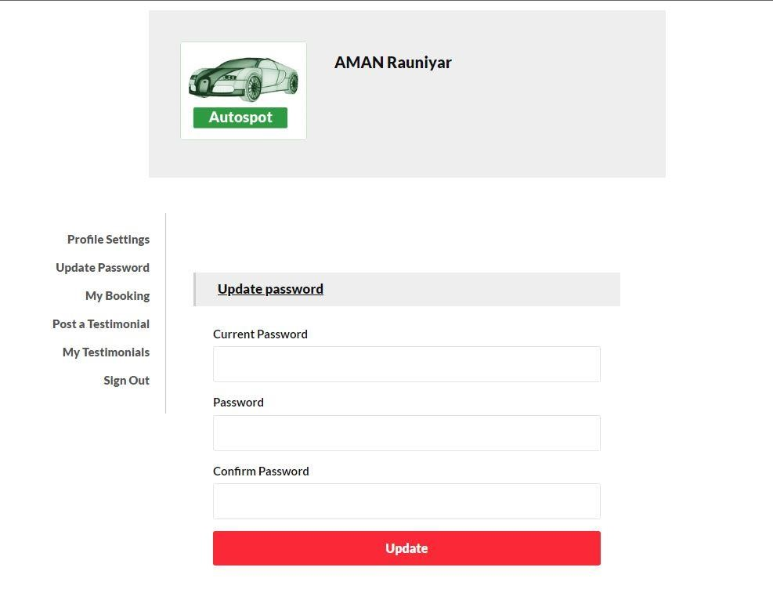

Fig : Update Password

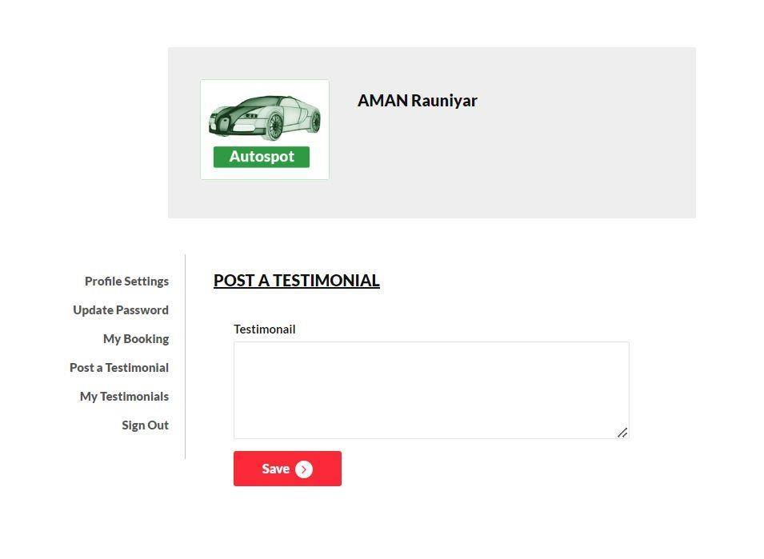

Fig : Testimonial

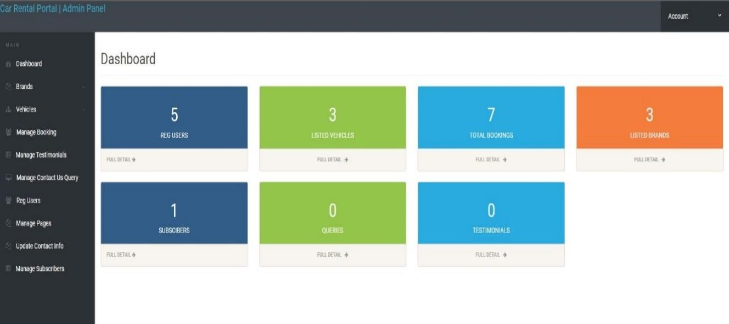

Fig : Admin Dashboard

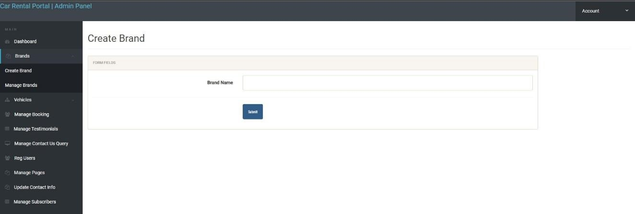

Fig : Create Brand

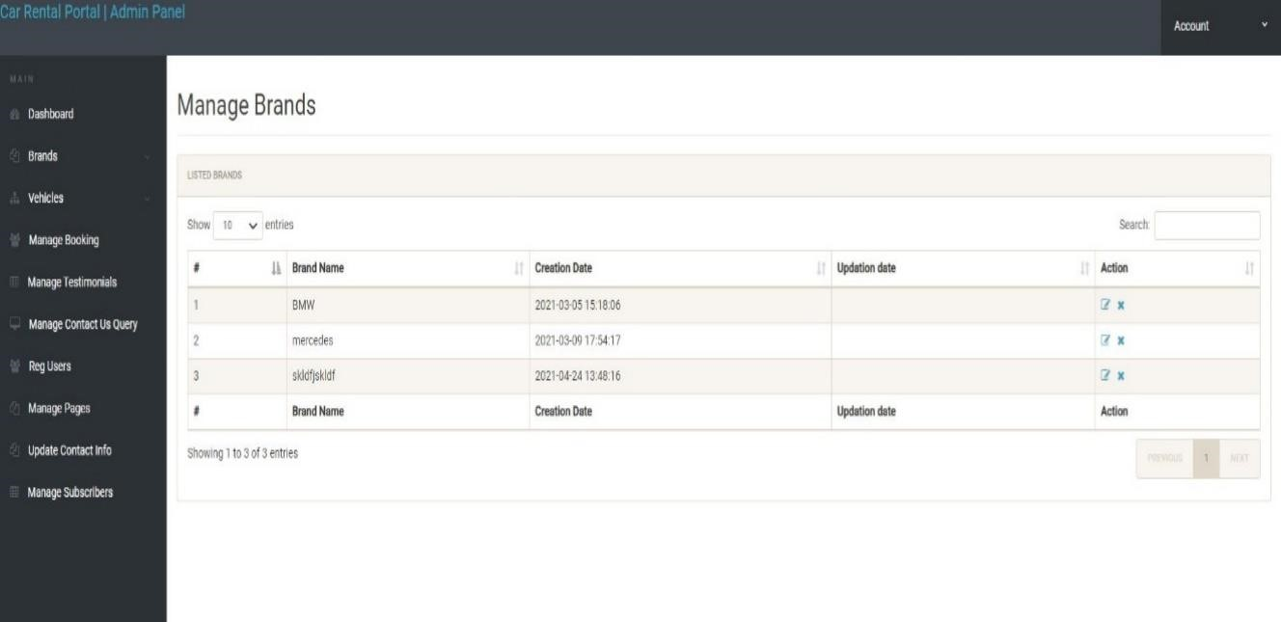

Fig : Manage Brand

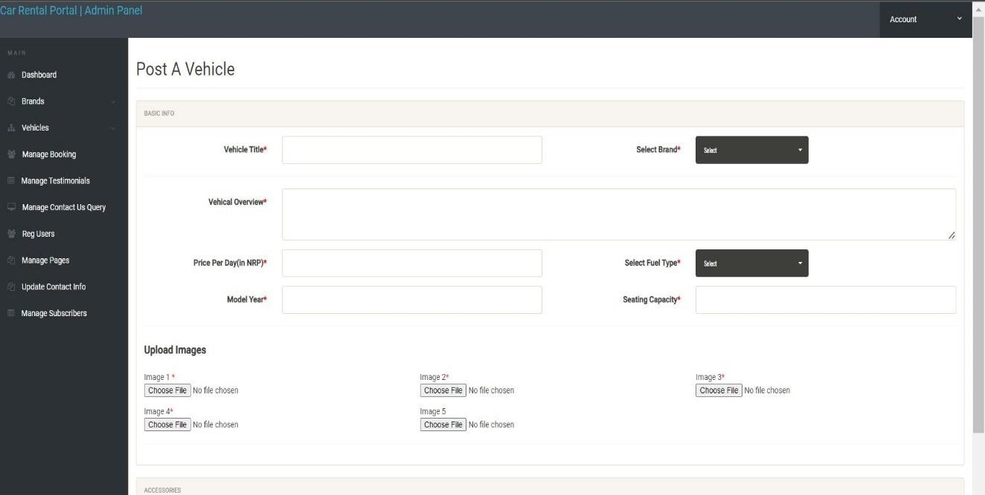

Fig : Post vehicle

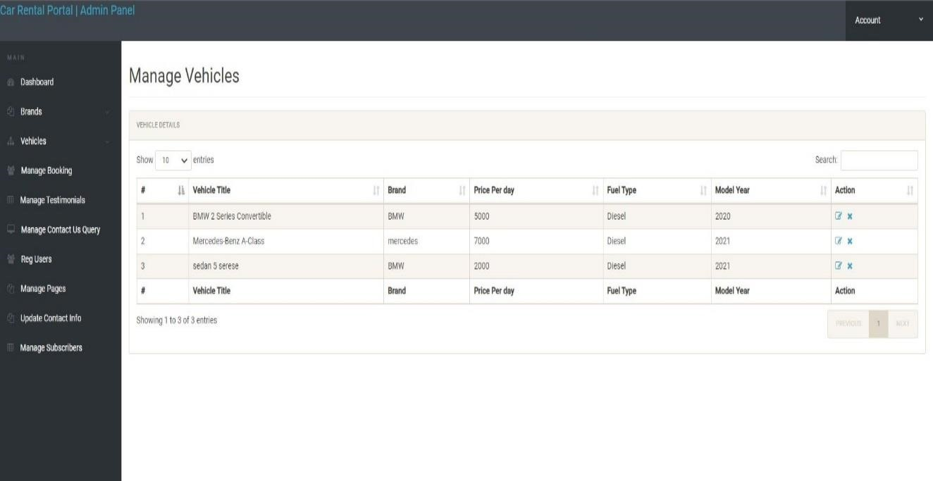

Fig : Manage Vehicle

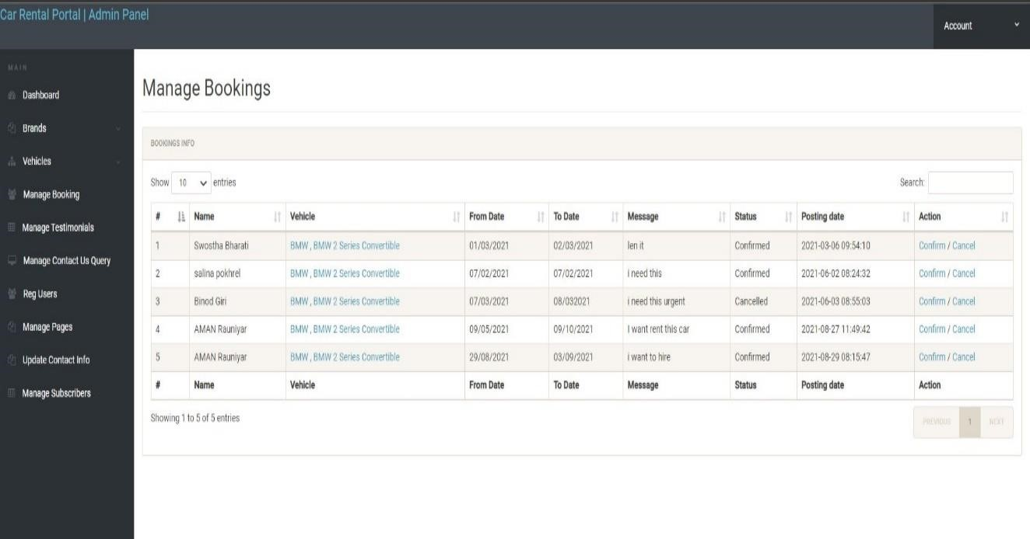

Fig : Manage Bookings

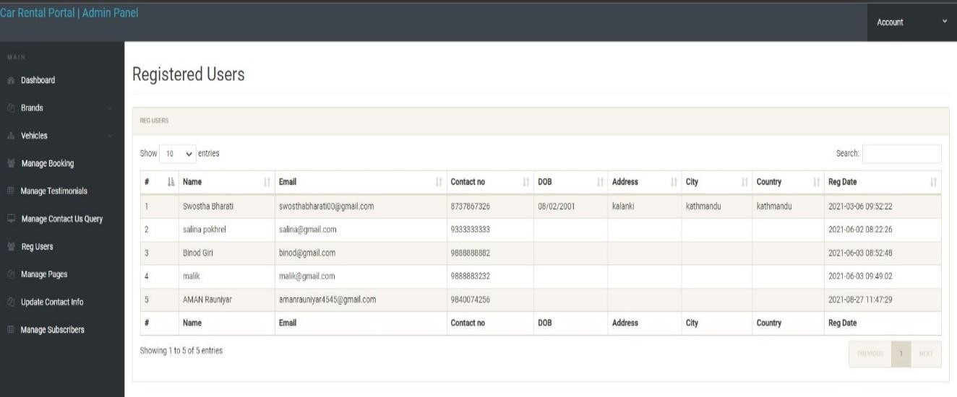

Fig : Registered Users

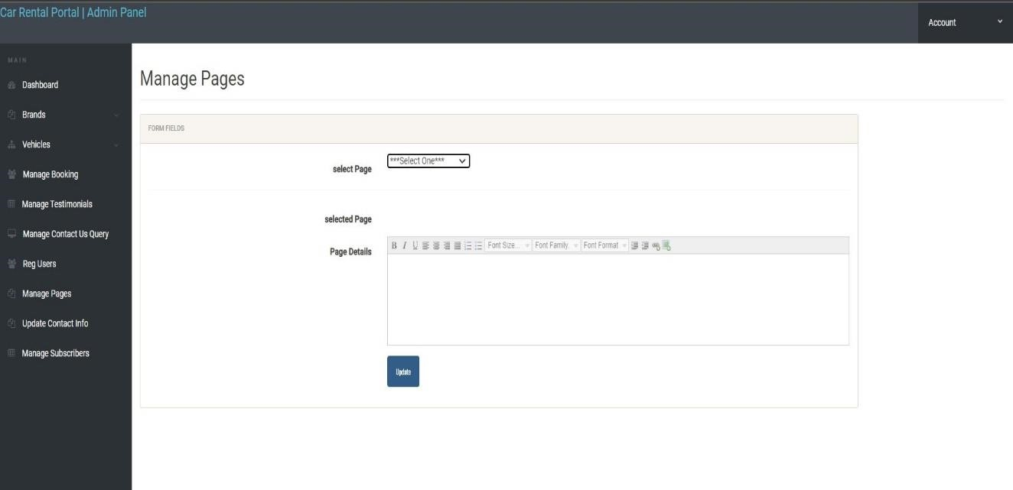

Fig : Manage Pages

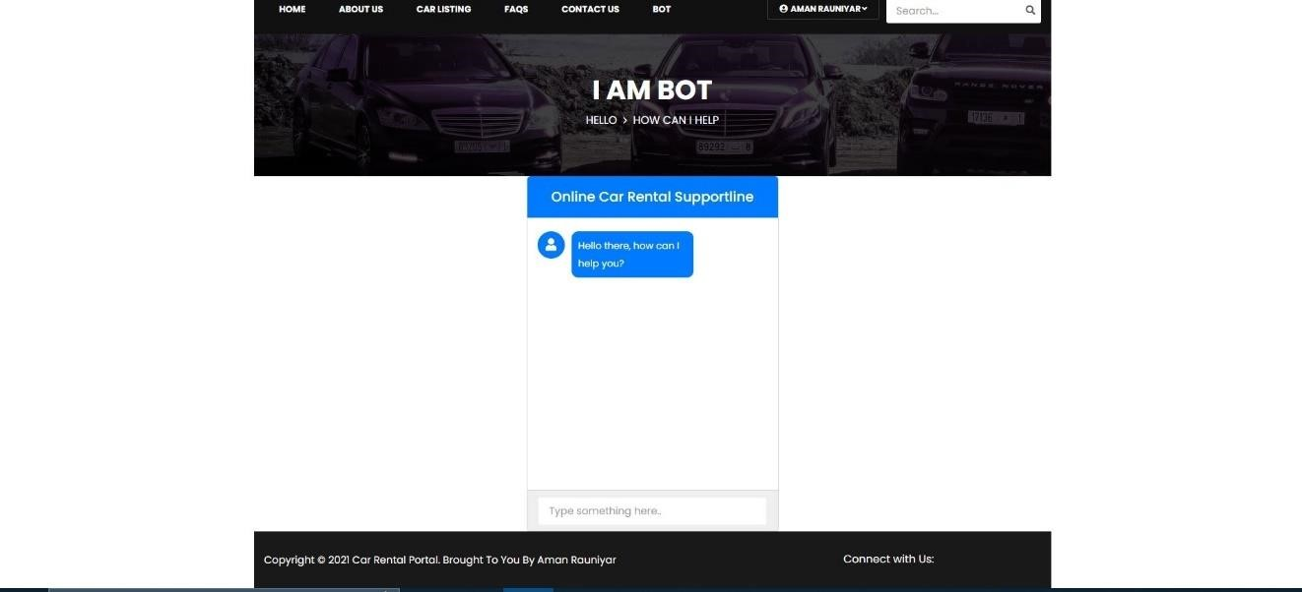

Fig : Bot